19) Aim: Design Turing Machine using simulator to perform addition of ‘aa’ and ‘aaa’.

Diagram:

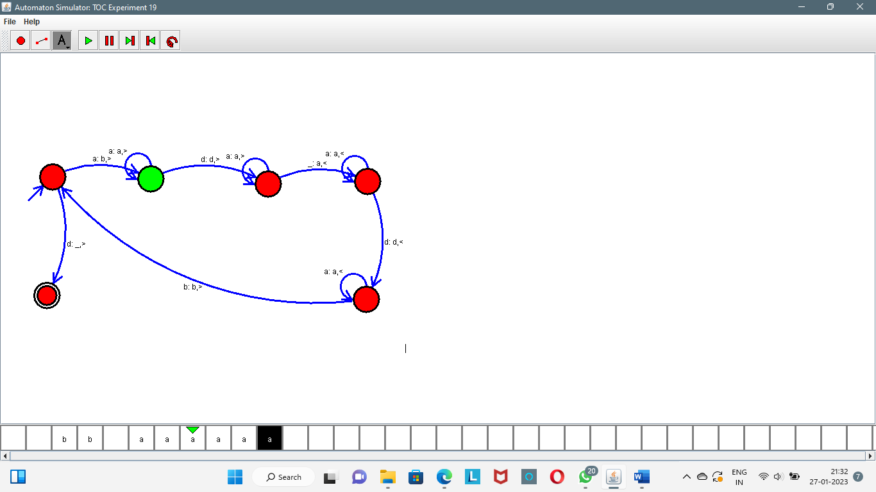

Result:

Successfully executed Turing Machine using simulator to perform addition of ‘aa’ and ‘aaa’.